**DAILY ONLINE ACTIVITIES SUMMARY**

|  |  |  |  |  |  |
| --- | --- | --- | --- | --- | --- |
| **Date:** | **31-05-2020** | | **Name:** | **Shanbhag Atish Manoj** | |
| **Sem & Sec** | **6th - B** | | **USN:** | **4AL17CS085** | |
| **Online Test Summary** | | | | | |
| **Subject** | **-** | | | | |
| **Max. Marks** | **-** | **Score** | | **-** | |
| **Certification Course Summary** | | | | | |
| **Course** | **Robotic Process Automation** | | | | |
| **Certificate Provider** | **GUVI** | **Duration** | | | **3 Hours** |
| **Coding Challenges** | | | | | |
|  | | | | | |
| **Status: executed** | | | | | |
| **Uploaded the report in GitHub** | | **Yes** | | | |
| **If yes Repository name** | | <https://github.com/atish-shanbhag/Updates> | | | |
| **Uploaded the report in slack** | | **Yes** | | | |

Certification Course Details:

Report

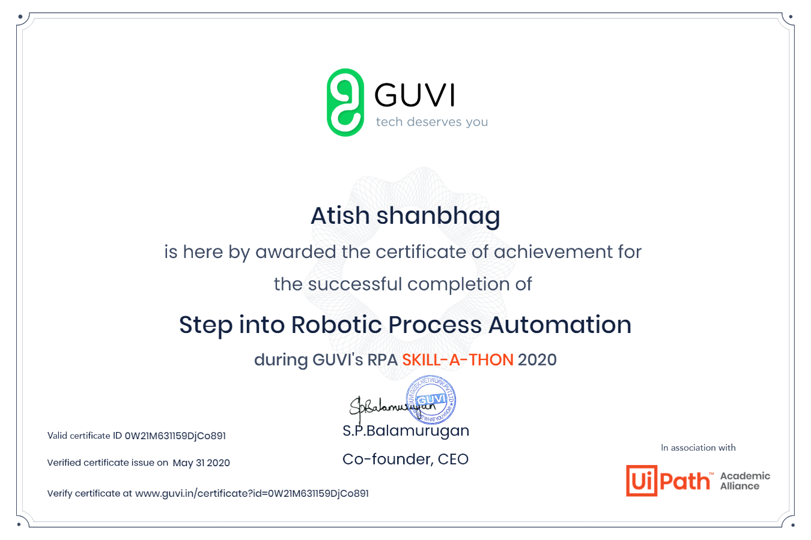

In today’s session for online certification successfully completed the course of Robotic Process Automation by Guvi’s RPA skill-a-thon as it had basic concepts related to RPA and had activities as mcq.

Coding Challenges Details:

The below GitHub link for details

<https://github.com/atish-shanbhag/Updates>

P-1

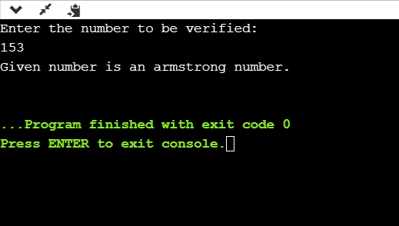

**Java program to check whether given is Armstrong or not.**

**P-2**

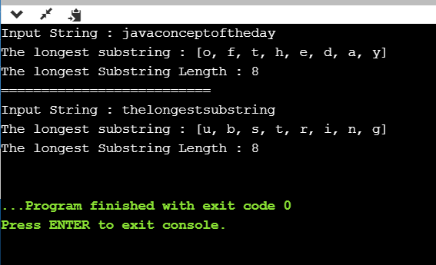

**Java program to calculate longest substring length of given string.**